**Your Local Store**

*UML Use Case Diagram*

The customer uses this application to make purchases from nearby shops. Top level use cases are Client login, Make purchases and Client Registration. Customer can login using an existing account or register as new user and create a new one. He / She can also use Google or Facebook account for login. Shop owner and delivery person can login using an already existing account. Customer can also view items available in shops located in his/her locality, and make purchases by selecting the desired products. Note, that Checkout use case is included use case not available by itself - checkout is part of making purchase.

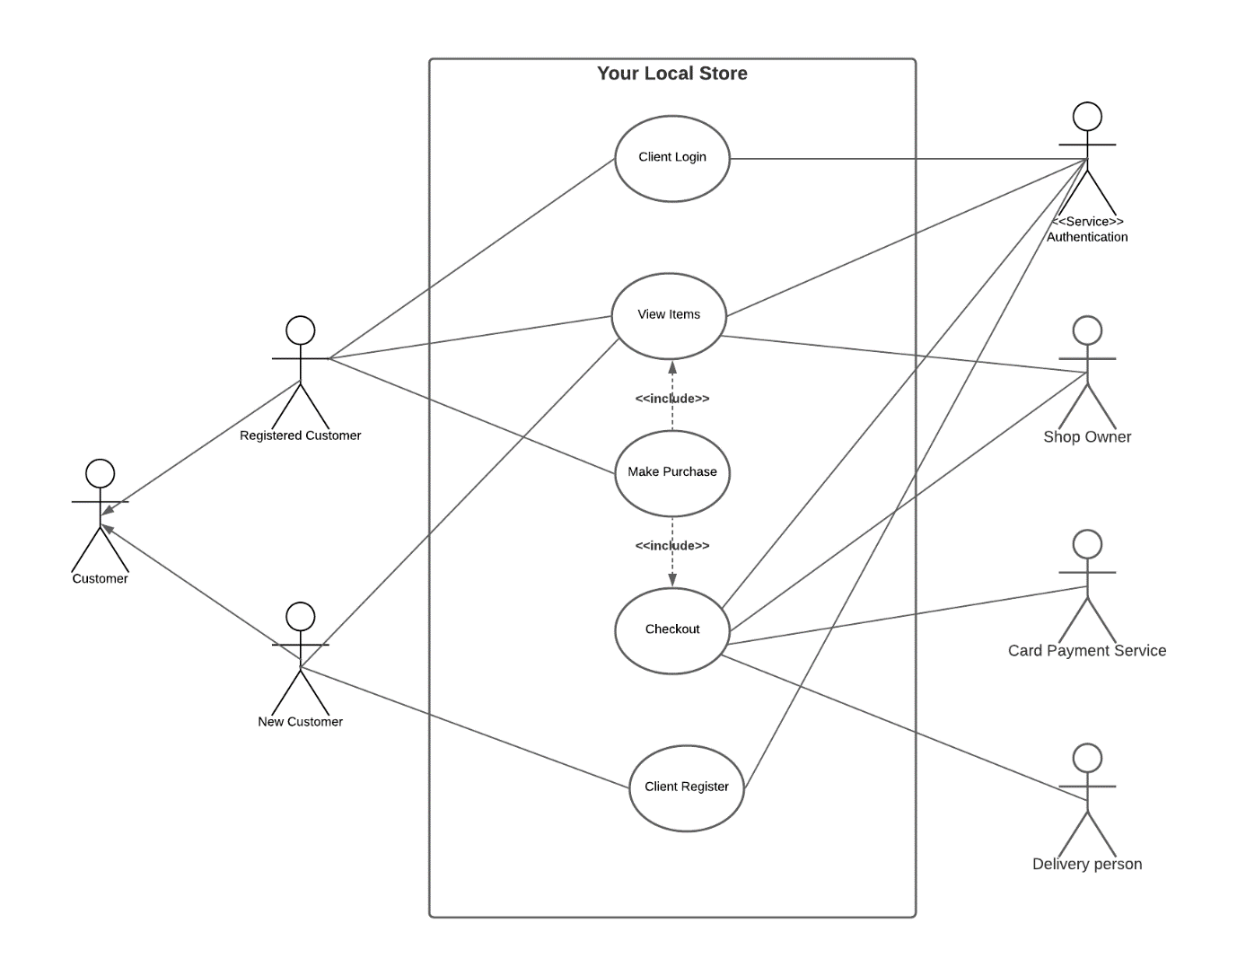

**View items** use case is extended by several optional use cases - customer may search for items, browse catalogue, view items recommended for him/her, add items to shopping cart or wish list. All these use cases are extended use cases because they provide some optional functions allowing customer to find item.

**Customer Authentication** use case is included in **View Recommended Items** and **Add to Wish List** because both require the customer to be authenticated. At the same time, item could be added to the shopping cart without user authentication.

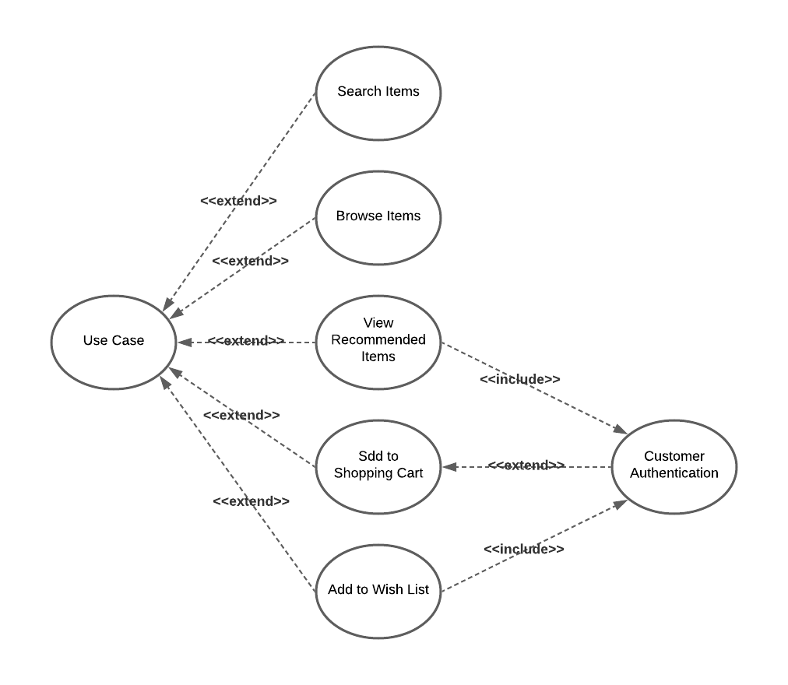

**Checkout**use case includes several required uses cases. Customer should be authenticated. Customer authentication service is used in all these use cases.

**Checkout** use case also includes **Payment** use case which could be done either by using credit card or using some other options.

